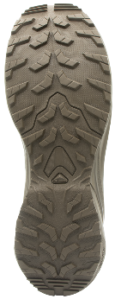

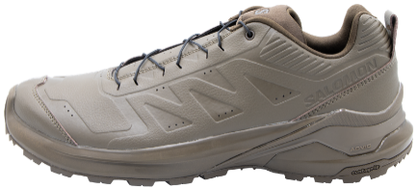

Manufacturer: Salomon SA
ZA des Croiselets
14 Chemin des Croiselets
74370 Epagny, Metz Tessy
France

Product Description:
The X ADVENTURE FORCES is a modern and lightweight shoe.
The upper material needs to be robust and very flexible. To meet these requirements, a non-reflective material mix of coated synthetic and knitwear stretch has been selected. The toe cap protects the foot from shocks and ensures high comfort. The Quicklace™ is a fast-lacing system to provide a secure, precise and almost customized fit.
The performance and stability of the sole construction play a crucial role. In combination, the Contagrip® MA outsole, Advanced Chassis™ and EnergyCell damping meet all performance requirements. An OrthoLite® inlay sole ensures a comfortable fit and additional damping in the boot.
The X ADENTURE FORCES is a perfect choice for anyone looking for a comfortable low-cut shoe.

Size Range:

Product Technology Highlights:
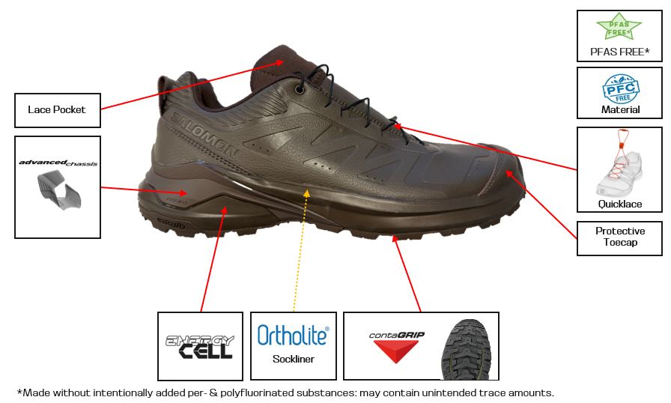

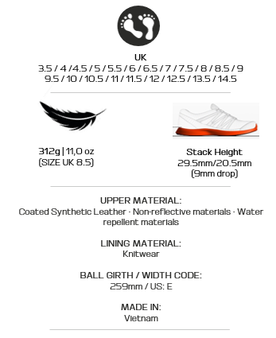

Technologies / Material | Description
Coated Synthetic Leather | Coated Synthetic Leather of 1.3mm thickness  A coated synthetic non woven backer that protects it and makes it stronger to last longer.
Non-reflective materials | Built to be discrete and non-reflective for Tactical use.
Lace Pocket | Tuck the excess lace and the buckle up inside the pocket on the tongue of the shoe.
QuicklaceTM Laces | Minimalistic and strong lace for one-pull tightening. Easy-on, easy-off.
Protective Toecap | 3D Toecap construction
Advanced Chassis™ | Advanced Chassis™ is a molded insert embedded in the outsole. Providing strong lateral support and reassuring protection, it also delivers optimal mobility and flexibility.
EnergyCell | A high-rebound midsole compound that provides exceptional energy return along with substantial cushioning and durability.
OrthoLite®  Insole | Ortholite® insoles provide step-in comfort and enhanced durability, breathability, moisture and odor control using a combination of special PU and rubber
Contagrip®  Outsole | Developed using All Terrain Contagrip, for adhesion and confidence on the widest variety of surfaces.

Table of Material:
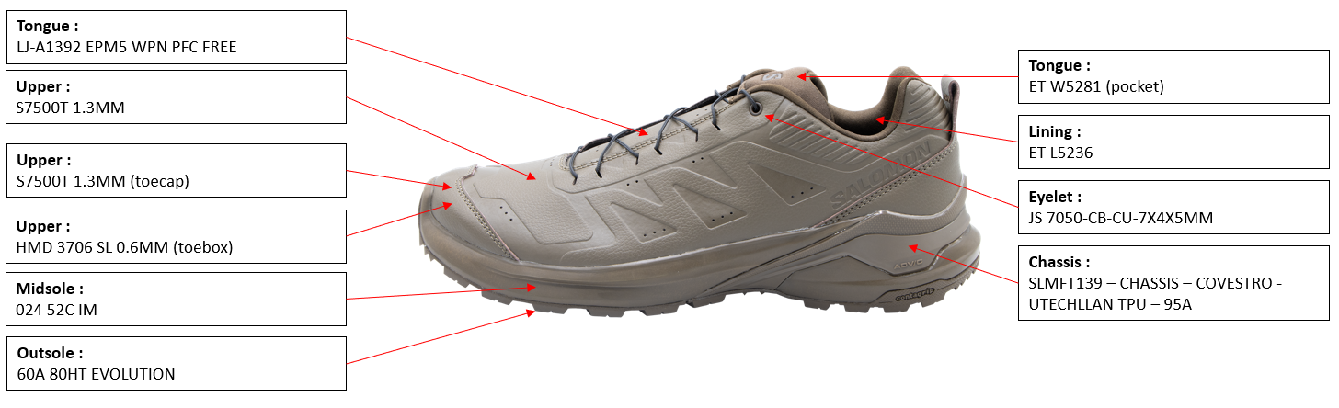

Sockliner Dimensions:
Ortholite – Molded single piece
